Rappaport Foundation Supports Artists For Humanity’s New Fellowship Program

Five Boston-based artists became the first cohort of The AFH Artists Fellowship program—offering mentorship, community and a public platform for local artists—as we build the connective tissue of our community.

Artists For Humanity has announced the launch of The AFH Artists Fellowship program with five inspiring Boston-based artists—Amril Foster, Ayana Mack, Kevin Nguyen, Naijah "Nine" Garrett, and Michael Talbot—through the generous support from the Phyllis and Jerome Lyle Rappaport Foundation, in honor of Adele Fleet Bacow and Larry Bacow, with additional support from the 2021 New England Patriots Players’ Social Justice Fund.

Over the next six-months, the Fellows will embark on a journey to advance their artistic goals in mentorship with AFH Co-founder and Managing Director of Alumni Programs, Rob “ProBlak” Gibbs, while contributing to a growing and thriving intergenerational artistic community here at AFH.

Rob, a visual artist and organizer who has transformed the cultural landscape of Boston through graffiti art since 1991, shares, “Our Fellows came in as teens or mentors. They were active in creating what AFH is, and then went out into the world as alumni. Now they have accepted our invitation to build a Fellowship and become ambassadors of what it means to be an Artist…For Humanity.”

The Fellows will provide yet another layer of role models for Boston's young people, working in parallel with AFH’s Youth Arts Enterprise while also sharing their journey and process with AFH teens.

We are grateful to the Rappaport Foundation and its Board for their forward vision and commitment to supporting The AFH Artists Fellowship. The Foundation is supporting the first two cohorts with a view to growing a longer partnership. Rappaport Foundation Executive Director, Timothy Medlock remarked, “Given their structure and programming, selecting Artists For Humanity as a partner was a natural choice for the Rappaport Foundation and its board. AFH complements the Rappaport Art Prize that we established in 2000 at the deCordova Museum. The Rappaport Art Prize has propelled the careers of celebrated artists such as Ursula von Rydingsvard, Titus Kaphar, and Abelardo Morell. We were eager to collaborate with an organization that provides training and mentorship to promising young artists in the early stages of their careers, and Artists For Humanity has an impressive national reputation for empowering Boston teens with opportunities for employment, education, and self-expression.”

The Rappaport Foundation has a legacy of funding talent and sponsors public policy fellowships at Harvard's Kennedy School and BC Law. Tim reflected on the AFH Artists Fellowship program, “We are thrilled to witness the growth and evolution of the fellows' artistry through this partnership."

The AFH Fellows
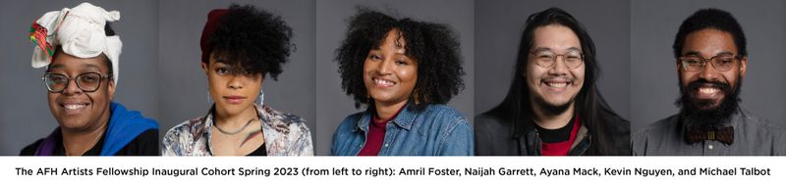
Amril Foster, also known as ‘Aqua One’ is a female artist and AFH alumna from Dorchester. A small business owner with a background in urban art, graffiti and mural work, Foster specializes in hand painted and airbrushed custom apparel as well as portraits on canvas.
Naijah "Nine" Garrett is a visual artist born and raised in Boston. As a young person, Nine used creativity as a main outlet for healing and self expression. A graduate of MassArt, Nine has been building a portfolio that reflects artivism and validation of marginalized communities. The pandemic propelled their mural work and large projects forward, as they found a calling to create more public art and push the boundaries of artmaking through experimentation.
An AFH alumna, Ayana Mack has been celebrated for her contribution to the Arts in the Commonwealth as a 2020 honoree for “Black Excellence on the Hill” and an active member of the arts community. Mack has worked with early-stage and established businesses/organizations and holds business development workshops for artists as she focuses on using art as a tool to create change within communities of color.
AFH Alumnus Kevin Nguyen grew up in Dorchester and Boston’s Chinatown, surrounded and inspired by the arts. Though holding a degree in graphic design, Nguyen learned that while design taught him how to view the world, working in a myriad of mediums expanded his view and offered different ways to create and tell stories.
Growing up in Jamaica, Michael Talbot has always had a strong desire to inspire and speak to others through art. Leaving his home country for the States, he began to pursue his artistic dreams doing illustration, graphic design and animation. He has been working as a Boston-based freelance artist ever since, working on a wide range of projects, murals, exhibitions and showcases. Talbot uses his early life in Jamaica to infuse, improve and “season” whatever project he tackles, providing some solace in a state of unrest to offer a balance of reality and wonder.

